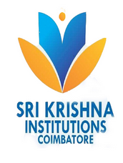 | SRI KRISHNA COLLEGE OF TECHNOLOGY  An Autonomous Institution  Coimbatore, Tamil Nadu | 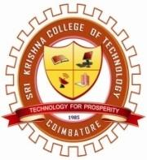

DEPARTMENT OF ELECTRICAL AND ELECTRONICS ENGINEERING
(Accredited By NBA Under Tier I)

The Department of Electrical and Electronics Engineering conducted workshop on "Intellectual Property Rights(IPRs) and IP management for Startup" facilitated by Ms. D. Kanaga Durga, Embedded Developer, 3Q Technologies, Coimbatore on 27th March 2021 from 12:00 PM to 1:00 PM. The event was coordinated by Ms.V.Manimegalai, Assistant Professor, Ms.A.Gayathri, Asst.Professor, Mr.T.Bharani Prakash, Asst.Professor, EEE. Totally 40 Participants were attended in this workshop. In this session, Ms. D. Kanaga Durga had explained Importance of Intellectual property starts, copyrights and related rights, and various startup in industrial design

Recorded Link:

https://drive.google.com/file/d/11qvG2anrHeHHuFX0pOAOwunH_9FG1fsD/view?usp=sharing

social Media Link
https://www.facebook.com/SKCTEEEOFFICIAL/photos/a.336982731170215/351178356417319/

