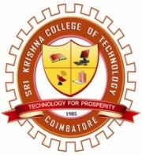 | SRI KRISHNA COLLEGE OF TECHNOLOGY  [An Autonomous Institution |Affiliated to Anna University and Approved by AICTE| Accredited by NAAC – UGC  KOVAIPUDUR, COIMBATORE - 641042. | 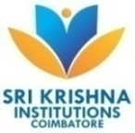
DEPARTMENT OF CIVIL ENGINEERING
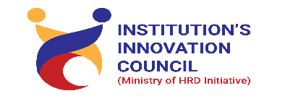
Brainstorming Idea Generation
14.09.2020

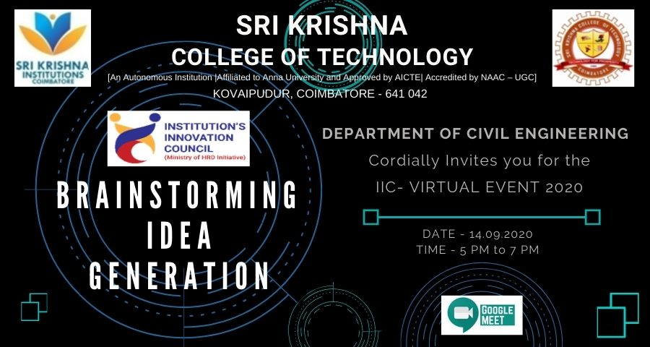
Brainstorming Idea Generation contest is an open innovation platform for all department students in our college to solve challenges for various problems. By this initiative idea contest the Department of Civil Engineering is targeting to solve many real-world problems. The main aim of this event is to provide the students a best platform to demonstrate their ideas, skills and creativity to develop unique and best solutions.
No. of Participants: 10 teams (36 Students)
Faculty Coordinator: Mr. J. Robinson
