SRI KRISHNA COLLEGE OF TECHNOLOGY
[An Autonomous Institution |Affiliated to Anna University and Approved by AICTE | Accredited by NAAC – UGC]
KOVAIPUDUR, COIMBATORE - 641042.
DEPARTMENT OF INSTRUMENTATION AND CONTROL ENGINEERING

Title: Webinar on Entrepreneurship, Process Design & Development

Speaker: Ms R Devika, Research Fellow, Bharathiyar University, Coimbatore
Time: 07.02.2021, 05.0 PM.
Description:
Entrepreneurship is the creation or extraction of value. With this definition, entrepreneurship is viewed as change, generally entailing risk beyond what is normally encountered in starting a business, which may include other values than simply economic ones. More narrow definitions have described entrepreneurship as the process of designing, launching and running a new business, which is often initially a small business, or as the "capacity and willingness to develop, organize and manage a business venture along with any of its risks to make a profit." The people who create these businesses are often referred to as entrepreneurs. While definitions of entrepreneurship typically focus on the launching and running of businesses, due to the high risks involved in launching a start-up, a significant proportion of start-up businesses have to close due to "lack of funding, bad business decisions, government policies, an economic crisis, lack of market demand, or a combination of all of these. "In the field of economics, the term entrepreneur is used for an entity which has the ability to translate inventions or technologies into products and services.

Objectives:

Students should know about:
- Importance of Economics
- Important terms in Economics
- Entrepreneurship & Development

Outcomes:

Students came to know about:

- Importance of Economics
- Important terms in Economics
- Entrepreneurship & Development

Session Poster

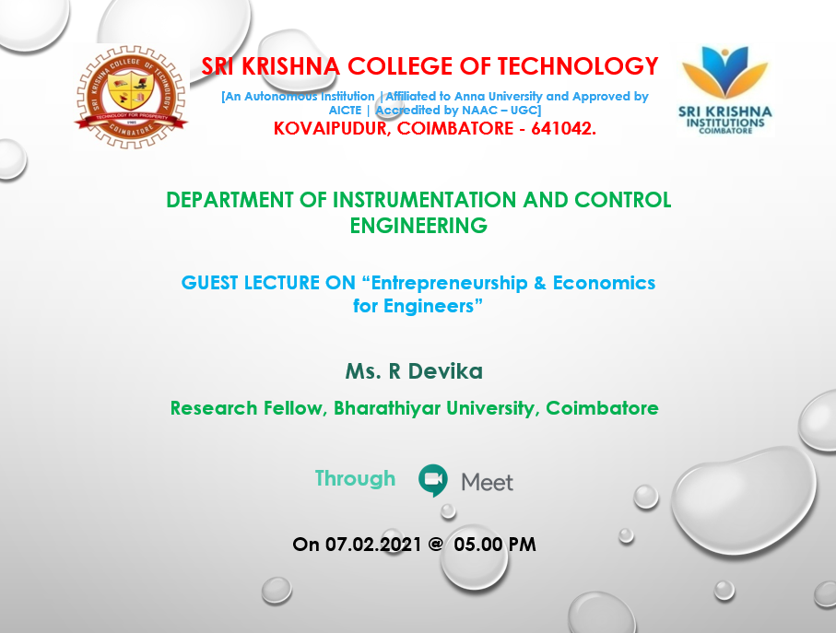

Session’s Glimpses

