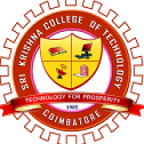 | Sri Krishna College of Technology  An Autonomous Institution, Accredited by NAAC with A Grade  Affiliated to Anna University, Accredited by NBA – AICTE  Kovaipudur, Coimbatore – 641042, Tamilnadu, India  www.skct.edu.in | 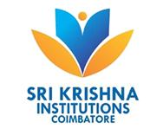
Report on the Webinar
Title: “Careers in Finance”
Date: 9th October 2021
Guest: Mr.S.Ramesh
Manager Hedge Fund Accounting
Morgan Stanley (Bangalore)
Number of Students Attended: 25 Students
Duration: 60 minutes
Platform: Google Meet
Meeting Link: https://meet.google.com/xtb-hegw-ahh
Video Link:
https://drive.google.com/file/d/1gPo1LJIvc21hiUkkzEonQDQQ6oKXwWeF/view
Content of the Program:
The webinar was organised for the Finance club members. The speaker addressed the job opportunities in investment banking. He presented the importance of NISM exams and what are the courses available for MBA students. The students interacted with the speakers by resizing the following questions?
- What are the job opportunities for non- finance students in MBA?
- What are the strategies to clear NISM exams?
- What are the current trends in the investment banking?
- What is the job opportunities presented in investment banking industry during pandemic?
- What are the skills required to get job in Investment banking Sector?

Invitation

Photos

