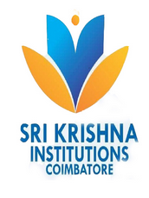 | SRI KRISHNA COLLEGE OF TECHNOLOGY  An Autonomous Institution  Coimbatore, Tamil Nadu | 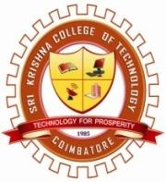
DEPARTMENT OF ELECTRICAL AND ELECTRONICS ENGINEERING
(Accredited By NBA Under Tier I)
The Department of Electrical and Electronics Engineering organized an Virtual Interactive Session on "Accelerators and Incubators for Early Stage Entrepreneurs"facilitated by Mr.S.Kavin Raja, B.E., M.S(Germany), Quality/Project Engineer, ARTS Solutions, Dresden, Germany on 12th March 2021 from 12.00 Pm to 01.30 Pm. The event was coordinated by Mr.P. Leninpugalhanthi, Asst. Professor Mr. R. Senthil Kumar, Asst.Professor, & Dr.S.Saravanan ,Assistant Professor, EEE. Totally 65 Participants were attended in this online interactive Sessin. Mr.S.Kavin Raja had explained, Accelerators and incubators in India,Stages of Entreprenurship, Methods of Generating Ideas, Scalable Start up Entrepreneur Goals and Career Opportunities in Abroad countries .
Recorded Link: https://drive.google.com/file/d/17F9rHXPeKrGA7a4qIU5qE5zoxEmFASDA/view?usp=sharing

Social Media Link
https://www.facebook.com/SKCTEEEOFFICIAL/photos/a.336982731170215/351177956417359/

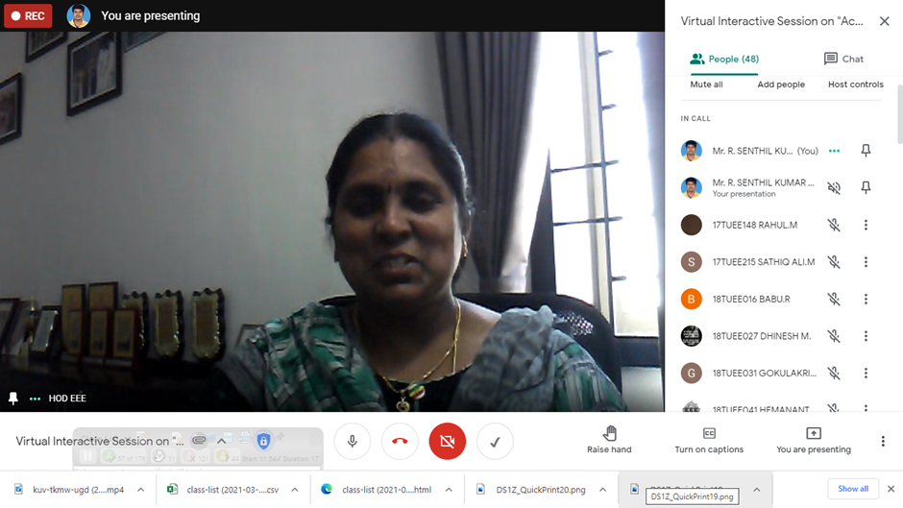

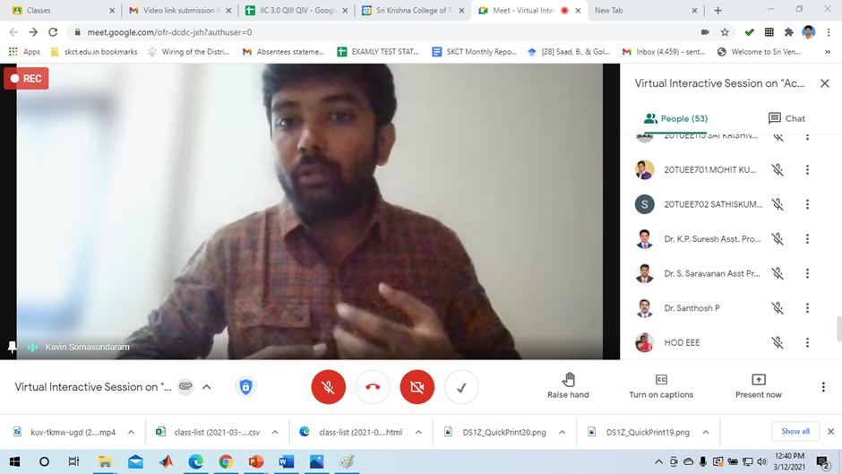

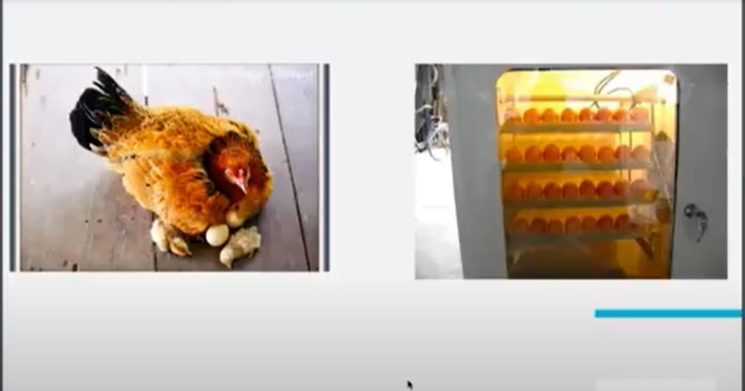

Sample Feedbacks
