Report of Webinar on "How to plan for Start-up and legal & Ethical Steps"
Organising Agency / Department | CSE
Date | 28.03.2021
Time | 4 pm to 5 pm
Resource Person(s) | Mr. Sam Suresh  Founder – Yemi Foundation, Coimbatore
Session’s Glimpses
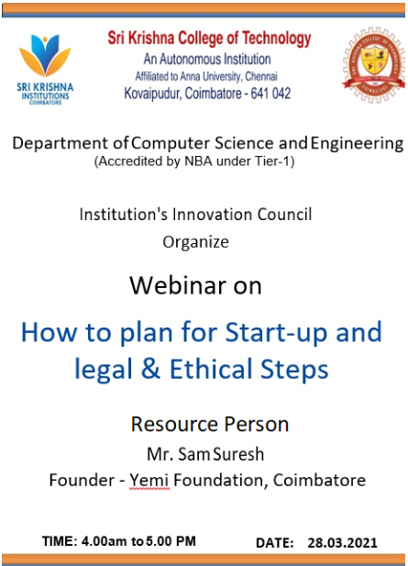
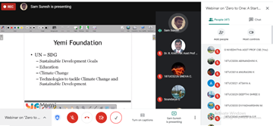 |  | 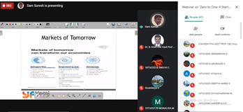
Objectives:
Students should know
- how to plan for start-up and
- legal & ethical steps
Description:
- Phases of Developing Start-up
- Innovative start-up’s History
- Research to Start-up Initiative
- Development of solution to local needs – Volunteering, Collaborating
Outcome:
Students came to know about
- how to plan for start-up and
- legal & ethical steps

